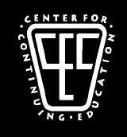

OFFICIAL SIGN-IN SHEET
RECORD OF ATTENDANCE FOR CALIFORNIA MCLE

PROVIDER: CENTER FOR CONTINUING EDUCATION
SUBJECT MATTER/TITLE: _____________________________________________
DATE/TIME OF AUDIO/VIDEO ACTIVITY: _______________________________
LOCATION: _________________________________________________________
LENGTH OF ACTIVITY: _______________

ELIGIBLE CALIFORNIA MCLE CREDIT (# OF HOURS): _____
NAME OF ATTENDEE: _____________________________

EMAIL ADDRESS: __________________________________

CALIFORNIA STATE BAR NUMBER: ________________

ATTENDEE SIGNATURE: ___________________________
MAIL ORIGINAL DOCUMENTS TO CCE:
CCE
395 DEL MONTE CENTER #178
MONTEREY, CA 93940

